Практическая работа №7 “События C#”

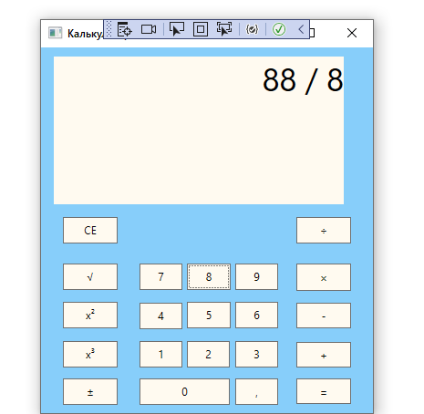

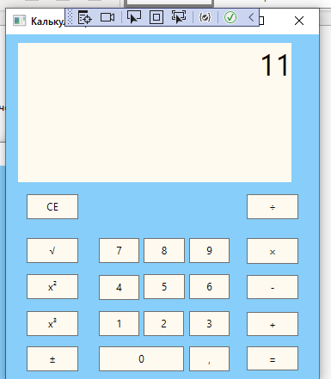

Код:

<Window x:Class="калькуляторр.MainWindow"

xmlns="http://schemas.microsoft.com/winfx/2006/xaml/presentation"

xmlns:x="http://schemas.microsoft.com/winfx/2006/xaml"

xmlns:d="http://schemas.microsoft.com/expression/blend/2008"

xmlns:mc="http://schemas.openxmlformats.org/markup-compatibility/2006"

xmlns:local="clr-namespace:калькуляторр"

mc:Ignorable="d"

Title="Калькулятор" Height="437" Width="380" Background="LightSkyBlue" MaxHeight="440" MaxWidth="380" MinHeight="440" MinWidth="380">

<Grid Margin="-18,0,0,0">

<TextBlock TextAlignment="Right" FontSize="35" Height="162" Margin="10" TextWrapping="Wrap" VerticalAlignment="Top" Background="FloralWhite" Name="scrin" HorizontalAlignment="Center" Width="318"/>

<Button Content="CE" HorizontalAlignment="Left" Height="29" Margin="42,0,0,0" VerticalAlignment="Center" Width="60" Background="FloralWhite" Name ="clear" Click="Clear"/>

<Button Click ="equals" Content="=" HorizontalAlignment="Left" Height="28" Margin="298,363,0,0" VerticalAlignment="Top" Width="60" Background="FloralWhite"/>

<Button Click ="root" Content="√" HorizontalAlignment="Left" Height="29" Margin="42,237,0,0" VerticalAlignment="Top" Width="60" Background="FloralWhite"/>

<Button Click ="degree2" Content="x²" HorizontalAlignment="Left" Height="29" Margin="42,279,0,0" VerticalAlignment="Top" Width="60" Background="FloralWhite"/>

<Button Click ="plus_minus" Content="±" HorizontalAlignment="Left" Height="29" Margin="42,363,0,0" VerticalAlignment="Top" Width="60" Background="FloralWhite"/>

<Button Click ="multi" Content="×" HorizontalAlignment="Left" Height="30" Margin="298,237,0,0" VerticalAlignment="Top" Width="60" Background="FloralWhite"/>

<Button Click ="minus" Content="-" HorizontalAlignment="Left" Height="28" Margin="298,280,0,0" VerticalAlignment="Top" Width="60" Background="FloralWhite"/>

<Button Click ="plus" Content="+" HorizontalAlignment="Left" Height="28" Margin="298,323,0,0" VerticalAlignment="Top" Width="60" Background="FloralWhite"/>

<Button Click ="num2" Content="2" HorizontalAlignment="Left" Height="29" Margin="178,322,0,0" VerticalAlignment="Top" Width="47" Background="FloralWhite"/>

<Button Click ="num1" Content="1" HorizontalAlignment="Left" Height="29" Margin="126,322,0,0" VerticalAlignment="Top" Width="47" Background="FloralWhite"/>

<Button Click ="num3" Content="3" HorizontalAlignment="Left" Height="29" Margin="231,322,0,0" VerticalAlignment="Top" Width="47" Background="FloralWhite"/>

<Button Click ="num5" Content="5" HorizontalAlignment="Left" Height="29" Margin="178,279,0,0" VerticalAlignment="Top" Width="48" Background="FloralWhite"/>

<Button Click ="num8" Content="8" HorizontalAlignment="Left" Height="29" Margin="178,237,0,0" VerticalAlignment="Top" Width="48" Background="FloralWhite"/>

<Button Click ="num6" Content="6" HorizontalAlignment="Left" Height="29" Margin="231,279,0,0" VerticalAlignment="Top" Width="47" Background="FloralWhite"/>

<Button Click ="num4" Content="4" HorizontalAlignment="Left" Height="29" Margin="126,280,0,0" VerticalAlignment="Top" Width="47" Background="FloralWhite"/>

<Button Click ="num7" Content="7" HorizontalAlignment="Left" Height="29" Margin="126,237,0,0" VerticalAlignment="Top" Width="47" Background="FloralWhite"/>

<Button Click ="num9" Content="9" HorizontalAlignment="Left" Height="29" Margin="231,237,0,0" VerticalAlignment="Top" Width="47" Background="FloralWhite"/>

<Button Click ="comma" Content="," HorizontalAlignment="Left" Height="29" Margin="231,363,0,0" VerticalAlignment="Top" Width="47" Background="FloralWhite"/>

<Button Click ="num0" Content="0" HorizontalAlignment="Left" Height="29" Margin="126,363,0,0" VerticalAlignment="Top" Width="99" Background="FloralWhite"/>

<Button Click ="del" Content="÷" HorizontalAlignment="Left" Height="29" Margin="298,0,0,0" VerticalAlignment="Center" Width="60" Background="FloralWhite"/>

<Button Click ="degree3" Content="x³" HorizontalAlignment="Left" Height="29" Margin="42,322,0,0" VerticalAlignment="Top" Width="60" Background="FloralWhite"/>

</Grid>

</Window>

using System;

using System.Collections.Generic;

using System.ComponentModel;

using System.Linq;

using System.Text;

using System.Threading.Tasks;

using System.Windows;

using System.Windows.Controls;

using System.Windows.Data;

using System.Windows.Documents;

using System.Windows.Input;

using System.Windows.Media;

using System.Windows.Media.Imaging;

using System.Windows.Navigation;

using System.Windows.Shapes;

namespace калькуляторр

{

/// <summary>

/// Логика взаимодействия для MainWindow.xaml

/// </summary>

public partial class MainWindow : Window

{

public MainWindow()

{

InitializeComponent();

}

void Clear(object sender, RoutedEventArgs e)

{

scrin.Text = null;

}

void num1(object sender, RoutedEventArgs e)

{

scrin.Text += "1";

}

void num2(object sender, RoutedEventArgs e)

{

scrin.Text += "2";

}

void num3(object sender, RoutedEventArgs e)

{

scrin.Text += "3";

}

void num4(object sender, RoutedEventArgs e)

{

scrin.Text += "4";

}

void num5(object sender, RoutedEventArgs e)

{

scrin.Text += "5";

}

void num6(object sender, RoutedEventArgs e)

{

scrin.Text += "6";

}

void num7(object sender, RoutedEventArgs e)

{

scrin.Text += "7";

}

void num8(object sender, RoutedEventArgs e)

{

scrin.Text += "8";

}

void num9(object sender, RoutedEventArgs e)

{

scrin.Text += "9";

}

void num0(object sender, RoutedEventArgs e)

{

scrin.Text += "0";

}

private void plus(object sender, RoutedEventArgs e)

{

if (scrin.Text.Length != 0 && !new char[5] { '+', '-', '*', '/', ','}.Contains(scrin.Text[scrin.Text.Length - 1]))

scrin.Text += " + ";

}

private void minus(object sender, RoutedEventArgs e)

{

if (scrin.Text.Length > 0 && !new char[5] { '+', '-', '*', '/', ',' }.Contains(scrin.Text[scrin.Text.Length - 1]))

scrin.Text += " - ";

}

private void multi(object sender, RoutedEventArgs e)

{

if (scrin.Text.Length != 0 && !new char[5] { '+', '-', '*', '/', ',' }.Contains(scrin.Text[scrin.Text.Length - 1]))

scrin.Text += " * ";

}

private void del(object sender, RoutedEventArgs e)

{

if (scrin.Text.Length != 0 && !new char[5] { '+', '-', '*', '/', ',' }.Contains(scrin.Text[scrin.Text.Length - 1]))

scrin.Text += " / ";

}

private void comma(object sender, RoutedEventArgs e)

{

if (scrin.Text.Length != 0 && !new char[5] { '+', '-', '*', '/', ',' }.Contains(scrin.Text[scrin.Text.Length - 1]))

scrin.Text += ",";

}

private void root(object sender, RoutedEventArgs e)

{

if (scrin.Text.Length != 0 && !new char[5] { '+', '-', '*', '/', ',' }.Contains(scrin.Text[scrin.Text.Length - 1]))

scrin.Text += " √";

}

private void degree2(object sender, RoutedEventArgs e)

{

if (scrin.Text.Length != 0 && !new char[5] { '+', '-', '*', '/', ',' }.Contains(scrin.Text[scrin.Text.Length - 1]))

scrin.Text += "² ";

}

private void degree3(object sender, RoutedEventArgs e)

{

if (scrin.Text.Length != 0 && !new char[5] { '+', '-', '*', '/', ',' }.Contains(scrin.Text[scrin.Text.Length - 1]))

scrin.Text += "³ ";

}

private void plus_minus(object sender, RoutedEventArgs e)

{

if (scrin.Text.Length != 0 && !new char[5] { '+', '-', '*', '/', ',' }.Contains(scrin.Text[scrin.Text.Length - 1]))

scrin.Text += " ± ";

}

private void equals(object sender, RoutedEventArgs e)

{

if (scrin.Text.Trim().Length == 0)

{

return;

}

try

{

scrin.Text = Eval(scrin.Text).ToString();

}

catch (OverflowException)

{

MessageBox.Show("Слишком длинное выражение", "Ошибка!", MessageBoxButton.OK, MessageBoxImage.Error);

}

catch (DivideByZeroException)

{

MessageBox.Show("Деление на ноль", "Ошибка!", MessageBoxButton.OK, MessageBoxImage.Error);

}

catch (Exception Ex)

{

MessageBox.Show("Ошибка!");

}

}

static Double Eval(String expression)

{

System.Data.DataTable table = new System.Data.DataTable();

return Convert.ToDouble(table.Compute(expression, String.Empty));

}

protected override void OnClosing(CancelEventArgs e)

{

e.Cancel = MessageBox.Show("Выйти из калькулятора?", "Подтвердите действие", MessageBoxButton.YesNo, MessageBoxImage.Question) == MessageBoxResult.No;

}

}

}